computer science - C++

Lesson 40: Stacks

OBJECTIVES: The student will use stacks to solve a non-recursive inorder tree traversal.

ACTIVITIES/TIME: Two Days:

Day one: Presentation - 35 minutes
Lab Exercise - 15 minutes
Days two: Lab Exercise

MATERIALS: Student Outline O.A.40.1
Transparency T.A.40.1, Printing a Binary Tree
Handout H.A.40.1, apstack
Lab Exercise L.A.40.1, Inorder
Answer Sheet L.A.40.1

REFERENCES: Adams, Joel, Sanford Leestma, and Larry Nyhoff. C++, An Introduction to Computing. Chapter 16.

Savitch, Walter. Problem Solving with C++. Pages 757-763.

INSTRUCTOR
NOTES: In this lesson, stacks will be taught as an abstraction. The apstack class will be used in programs which need a stack data type. The lab will require a stack of tree pointers to support a non-recursive inorder function. The function will be given in pseudocode form. You are encouraged to give a general overview of the algorithm without providing detail. A transparency of a binary tree T.A.40.1, Printing a Binary Tree, is provided as a sample tree to work through. Label each of these nodes with an address, preferably a hexadecimal value (0..9 & A..F characters). As you work through the pseudocode, illustrate how the hexadecimal addresses are pushed and popped off the stack to solve the problem.

Student Outline

Lesson 40: Stacks

INTRODUCTION: When studying recursion you were introduced to the concept of a stack. A stack is a linear data structure with well defined insertion and deletion routines. The stack abstraction has been solved for you in the apstack class. After covering the member functions available in the apstack class the lab exercise will use stacks to solve a non-recursive inorder tree traversal problem.

The key topics for this lesson are:

A. The Stack Abstract Data Type
B. Implementation Strategies for a Stack Type

VOCABULARY: STACK POP
PUSH TOP

DISCUSSION: A. The Stack Abstract Data Type

1. The stack object is a linear data structure, with each node or cell holding the same data type.

2. All additions to and deletions from a stack occur at the top of the stack. The last item pushed onto the stack will be the first item removed. A stack is sometimes referred to as a LIFO structure, which stands for Last-In, First-Out.

3. Two of the more important stack operations involve pushing data onto a stack and popping data off the stack.

4. The push operation will look like this:

Push Operation

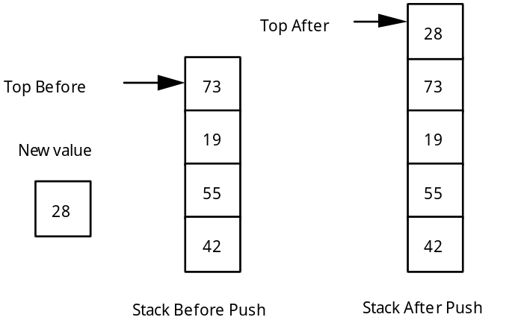

5. The pop operation will look like this:

Pop Operation:

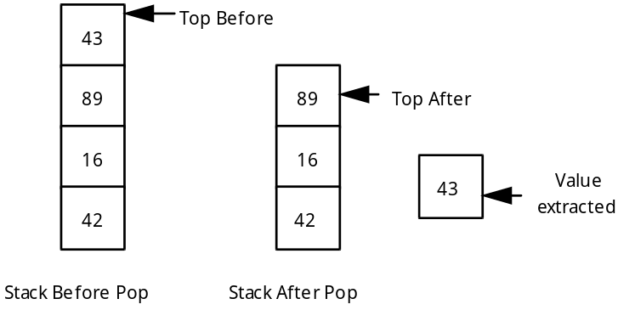

See Handout H.A.40.1, apstack. | 6. Here is a summary of the stack operations supported by the apstack class. See Handout H.A.40.1, apstack for the details.

Constructors

apstack(); constructs an empty stack
apstack (const apstack &s); copy constructor
~apstack (); destructor

Assignment

const apstack& operator= (const apstack& rhs);

Accessors

const itemType & top() const; returns top element with no pop
bool isEmpty() const; return true if stack is empty, else false
int length() const; returns length of stack

Modifiers

void push (const itemType & item); push item onto top of stack
void pop (); pop top element
void pop (itemType& item); combines pop and top
void makeEmpty(); empties stack

7. The distinction between top and pop follows: the top operation simply returns the top value in the stack while the pop operation removes the top value. Notice that the pop operation has been overloaded to either remove the top element, or to remove and return the top element.

8. Here is a short program illustrating usage of the apstack class.

// Example program of using apstack class

#include <iostream.h>
#include <apstack.h>

main()
{
apstack<int> stack;
int value;

for (int k=1; k<=5; k++)
stack.push(k);
while (!(stack.isEmpty()))
{
stack.pop(value);
cout << value << " ";
}
return 0;
}

B. Implementation Strategies for a Stack Type

1. The data structure used in the apstack class is an apvector. This allows for resizing of the stack as needed to make it larger. However the author of the apstack class did not resize the apvector smaller as the stack was popped. A vector is an appropriate data structure to use to implement a stack.

2. Another approach would be to use a linked list which would support true dynamic resizing. As you push data onto the stack another node is added to the appropriate end of the linked list. When data is popped from the stack, the linked list would be reduced in size.

3. A future lesson will teach you how to write templated classes. You will change the implementation of the apstack class while leaving the interface stable.

SUMMARY/REVIEW: The stack ADT is what makes recursive algorithms possible. In the lab exercise you will gain a better understanding of the recursive inorder function used to traverse a binary tree.

ASSIGNMENT: Lab Exercise L.A.40.1, Inorder

